HANDS ON EXPERIENCE – WEEK:3
SuperSet ID : 6389711
Name: MADHANGESH P B

EXERCISE 1: CONFIGURING A BASIC SPRING APPLICATION
SCENARIO
Your company is developing a web application for managing a library. You need to use the Spring Framework to handle the backend operations.
APPROACH
- Create a Maven project and add spring-context dependency in pom.xml.
- Create an applicationContext.xml in src/main/resources and define beans.
- Create BookRepository and BookService with a setter injection.
- Write a LibraryApp class to load the Spring context and retrieve the bookService bean.
- Run the app and see the output in the console.
CODE
pom.xml
Added following dependencies in pom.xml
<dependencies>
<dependency>
<groupId>org.springframework</groupId>
<artifactId>spring-context</artifactId>
<version>5.3.32</version> <!-- Latest stable Spring 5 -->
</dependency>
</dependencies>
applicationContext.xml
<?xml version="1.0" encoding="UTF-8"?>
<beans xmlns="http://www.springframework.org/schema/beans"
xmlns:xsi="http://www.w3.org/2001/XMLSchema-instance"
xsi:schemaLocation="http://www.springframework.org/schema/beans
http://www.springframework.org/schema/beans/spring-beans.xsd">
<bean id="bookRepository" class="com.library.repository.BookRepository"/>
<bean id="bookService" class="com.library.service.BookService">
<property name="bookRepository" ref="bookRepository"/>
</bean>
</beans>
BookRepository.java
package com.library.repository;
public class BookRepository {
public String getBookDetails() {
return "Spring in Action - Craig Walls";
}
}
BookService.java
package com.library.service;
import com.library.repository.BookRepository;
public class BookService {
private BookRepository bookRepository;
public void setBookRepository(BookRepository bookRepository) {
this.bookRepository = bookRepository;
}
public void displayBook() {
System.out.println("Book: " + bookRepository.getBookDetails());
}
}

LibraryApp.java
package com.library1;
import com.library.service.BookService;
import org.springframework.context.ApplicationContext;
import org.springframework.context.support.ClassPathXmlApplicationContext;
public class LibraryApp {
public static void main(String[] args) {
ApplicationContext context = new ClassPathXmlApplicationContext("applicationContext.xml");
BookService bookService = context.getBean("bookService", BookService.class);
bookService.displayBook();
((ClassPathXmlApplicationContext) context).close();
}
}
OUTPUT
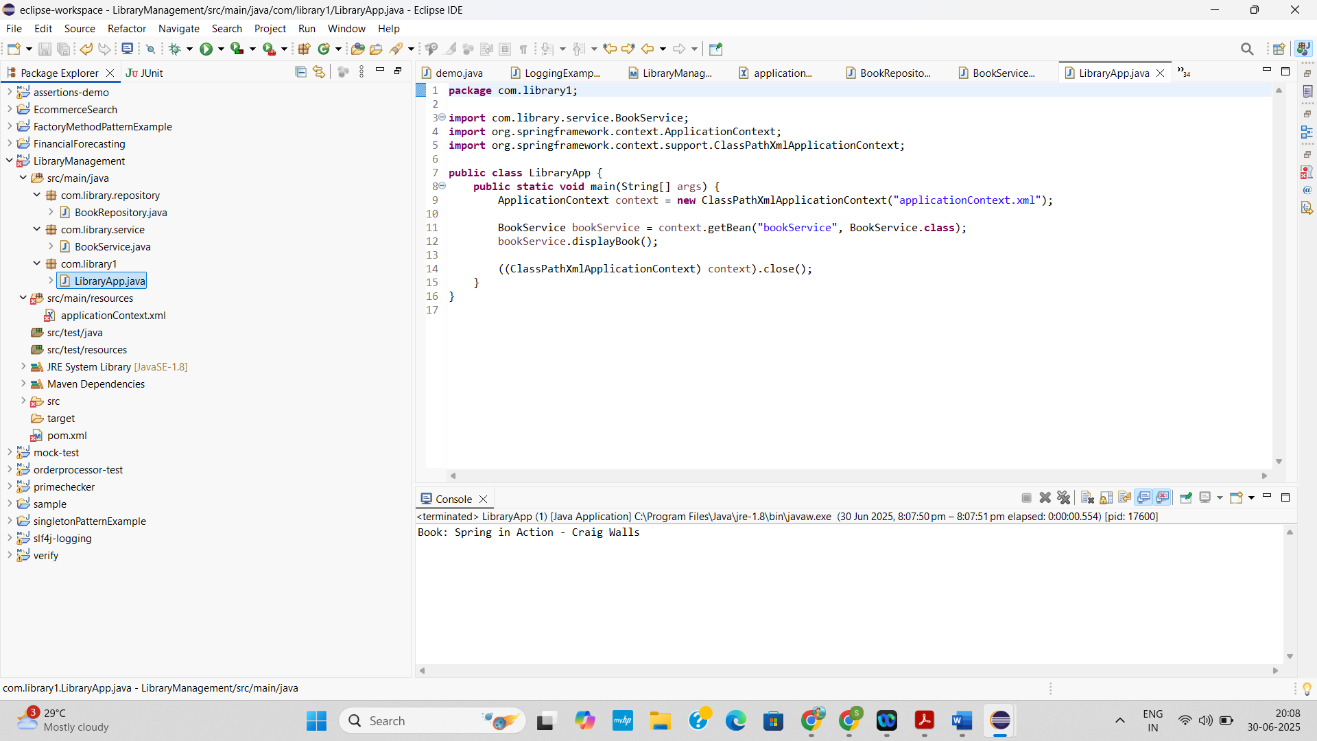

EXERCISE 2: IMPLEMENTING DEPENDENCY INJECTION
SCENARIO
In the library management application, you need to manage the dependencies between the BookService and BookRepository classes using Spring's IoC and DI.
APPROACH
- Define Beans: Declare bookRepository and bookService in applicationContext.xml.
- Setter Injection: Add a setter in BookService to receive the BookRepository.
- Bean Wiring: Link both beans using <property> in XML.
- Load Context: Use ClassPathXmlApplicationContext in your main class.
- Run & Test: Invoke service methods to confirm DI is working (check console output).
CODE
pom.xml
Added following dependencies in pom.xml
<dependencies>
<dependency>
<groupId>org.springframework</groupId>
<artifactId>spring-context</artifactId>
<version>5.3.30</version> <!-- You can use latest 5.x version -->
</dependency>
<dependency>
<groupId>org.springframework</groupId>
<artifactId>spring-beans</artifactId>
<version>5.3.30</version>
</dependency>

<dependency>
<groupId>org.slf4j</groupId>
<artifactId>slf4j-api</artifactId>
<version>1.7.36</version>
</dependency>
<dependency>
<groupId>org.slf4j</groupId>
<artifactId>slf4j-simple</artifactId>
<version>1.7.36</version>
</dependency>
</dependencies>
applicationContext.xml
<?xml version="1.0" encoding="UTF-8"?>
<beans xmlns="http://www.springframework.org/schema/beans"
xmlns:xsi="http://www.w3.org/2001/XMLSchema-instance"
xsi:schemaLocation="
http://www.springframework.org/schema/beans
http://www.springframework.org/schema/beans/spring-beans.xsd">
<bean id="bookRepository" class="com.library.repository.BookRepository"/>
<bean id="bookService" class="com.library.service.BookService">
<property name="bookRepository" ref="bookRepository"/>
</bean>
</beans>
BookRepository.java
package com.library.repository;
public class BookRepository {
public void saveBook(String title) {
System.out.println("Book saved: " + title);
}}
BookService.java
package com.library.service;
import com.library.repository.BookRepository;
public class BookService {
private BookRepository bookRepository;
public void setBookRepository(BookRepository bookRepository) {
this.bookRepository = bookRepository;
}
public void addBook(String title) {
bookRepository.saveBook(title);
}
}
LibraryManagementApplication.java
package com.library1;
import com.library.service.BookService;
import org.springframework.context.ApplicationContext;
import org.springframework.context.support.ClassPathXmlApplicationContext;
public class LibraryManagementApplication {
public static void main(String[] args) {
ApplicationContext context = new ClassPathXmlApplicationContext("applicationContext.xml");
BookService bookService = (BookService) context.getBean("bookService");
bookService.addBook("The Alchemist");
}
}

OUTPUT

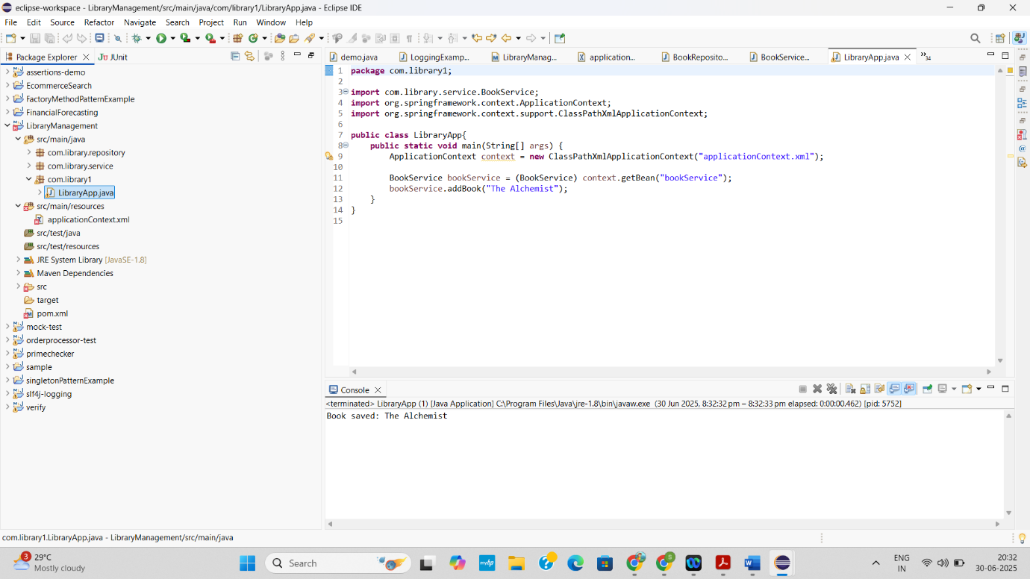

EXERCISE 4: CREATING AND CONFIGURING A MAVEN PROJECT
SCENARIO
You need to set up a new Maven project for the library management application and add Spring dependencies.
APPROACH
- Create a Maven project and add Spring dependencies in pom.xml.
- Write a simple service class (e.g., BookService) with a display method.
- Create applicationContext.xml and define the bean for BookService.
- In the main class, load the Spring context using ClassPathXmlApplicationContext.
- Retrieve the bean and call its method to verify Spring setup via console output.
CODE
pom.xml
Added following dependencies in pom.xml
<dependencies>
<dependency>
<groupId>org.springframework</groupId>
<artifactId>spring-context</artifactId>
<version>5.3.32</version>
</dependency>
<dependency>
<groupId>org.springframework</groupId>
<artifactId>spring-aop</artifactId>
<version>5.3.32</version>
</dependency>
<dependency>
<groupId>org.springframework</groupId>
<artifactId>spring-webmvc</artifactId>
<version>5.3.32</version>
</dependency>
</dependencies>
<build>
<plugins>
<plugin>
<groupId>org.apache.maven.plugins</groupId>
<artifactId>maven-compiler-plugin</artifactId>
<version>3.11.0</version>
<configuration>
<source>1.8</source>
<target>1.8</target>
</configuration>
</plugin>
</plugins>
</build>
applicationContext.xml
<?xml version="1.0" encoding="UTF-8"?>
<beans xmlns="http://www.springframework.org/schema/beans"
xmlns:xsi="http://www.w3.org/2001/XMLSchema-instance"
xsi:schemaLocation="http://www.springframework.org/schema/beans
http://www.springframework.org/schema/beans/spring-beans.xsd">
<bean id="bookService" class="com.library.BookService"/>
</beans>

BookService.java
package com.library;
public class BookService {
public void display() {
System.out.println("📚 BookService is working via Spring!");
}
}
App.java
package com.library;
import org.springframework.context.ApplicationContext;
import org.springframework.context.support.ClassPathXmlApplicationContext;
public class App {
public static void main(String[] args) {
ApplicationContext context = new ClassPathXmlApplicationContext("applicationContext.xml");
BookService service = context.getBean("bookService", BookService.class);
service.display();
}
}
OUTPUT
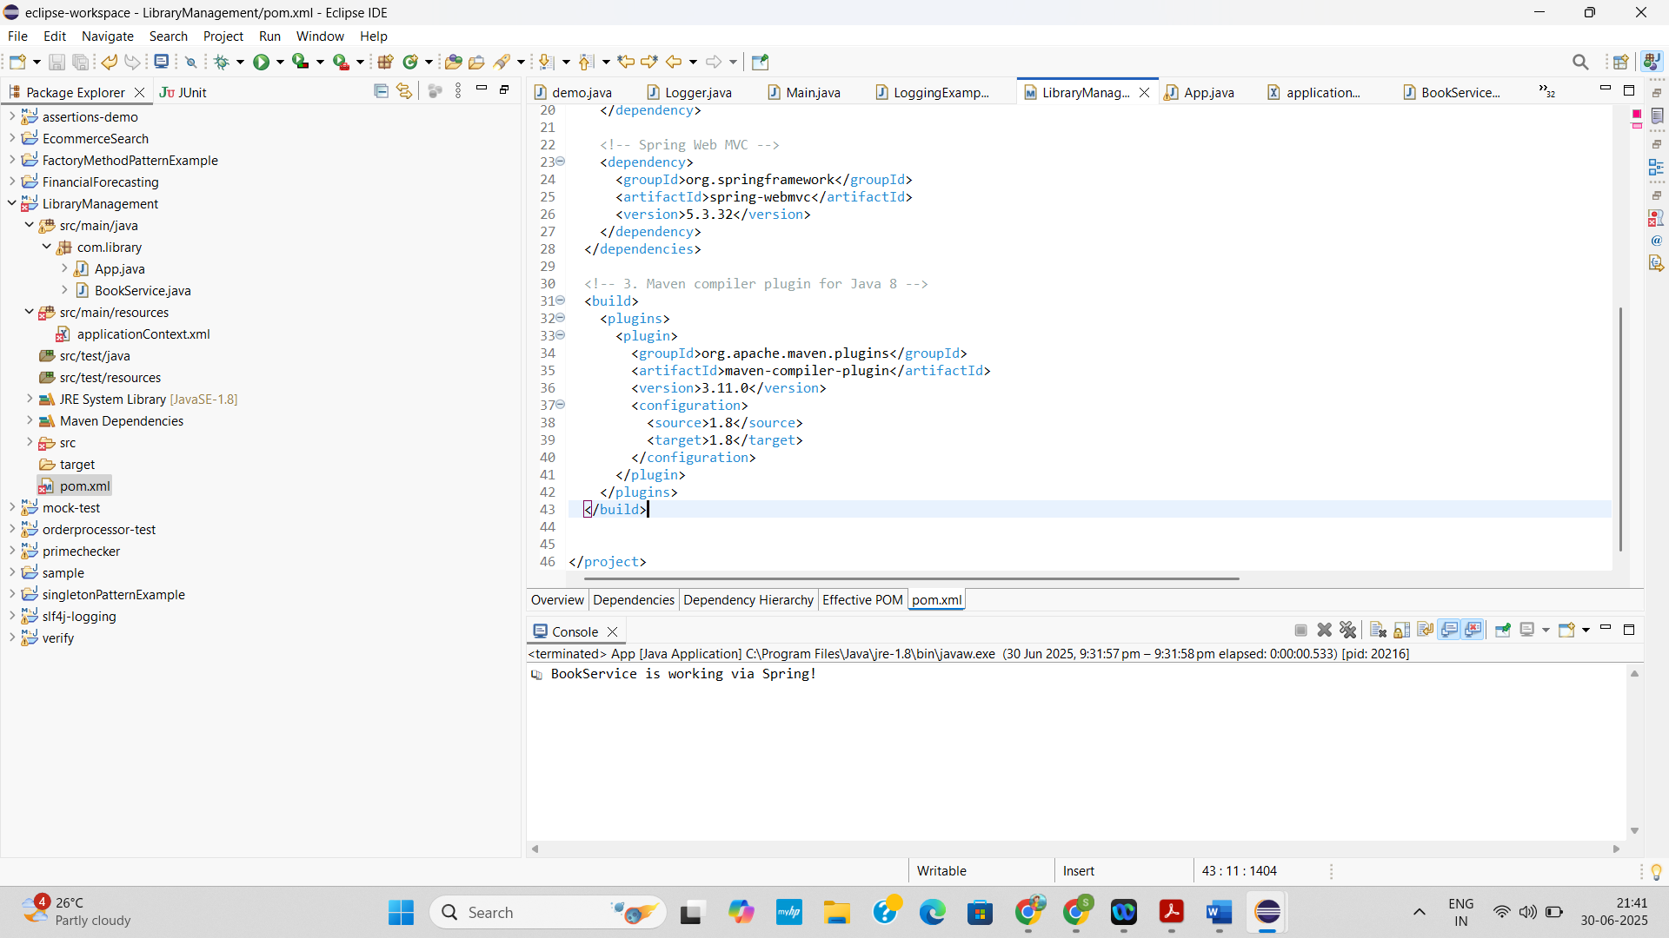

SPRING DATA JPA WITH SPRING BOOT, HIBERNATE

EXERCISE 01: SPRING DATA JPA - QUICK EXAMPLE
APPROACH
- Added the databases and log configuration in the application.properties file as per given.
- Included logs in the application and verified that the main() method is called. And the output is as follows:
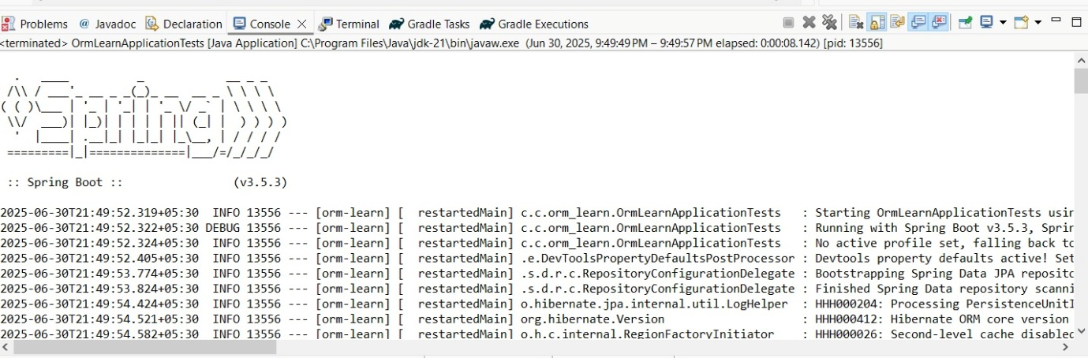
………
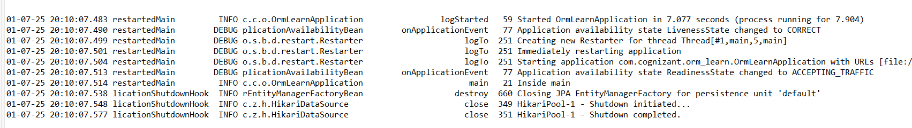
- And I also created table named “country” and entered the couple of records into the table as per the table.
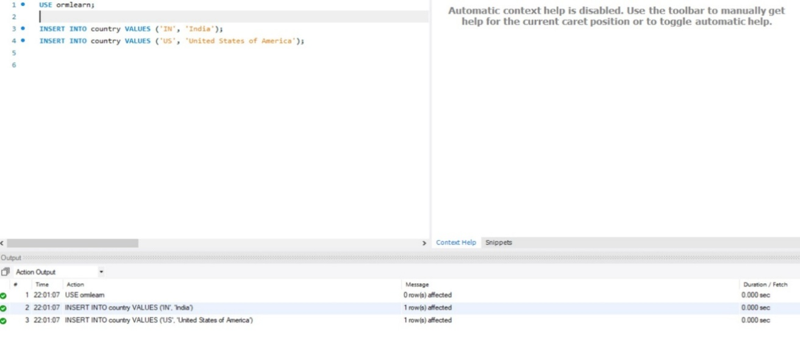

- The “Country.java” class is an entity that represents the country table in the database, with fields code and name mapped using JPA annotations.
- The “CountryRepository.java” interface extends JpaRepository to provide built-in CRUD operations for the Country entity without the need for boilerplate code.
- The “CountryService.java” class serves as the service layer, where business logic is implemented; it autowires the CountryRepository and provides methods like getAllCountries() to retrieve data from the database.
CODE
Country.java
package com.cognizant.orm_learn.model;
import jakarta.persistence.Column;
import jakarta.persistence.Entity;
import jakarta.persistence.Id;
import jakarta.persistence.Table;
@Entity
@Table(name = "country")
public class Country {
@Id
@Column(name = "code")
private String code;
@Column(name = "name")
private String name;
public String getCode() {
return code;
}
public void setCode(String code) {
this.code = code; }
public String getName() {
return name;
}
public void setName(String name) {
this.name = name;
}
@Override
public String toString() {
return "Country [code=" + code + ", name=" + name + "]";
}
}
CountryRepository.java
package com.cognizant.orm_learn.repository;
import org.springframework.data.jpa.repository.JpaRepository;
import org.springframework.stereotype.Repository;
import com.cognizant.orm_learn.model.Country;
@Repository
public interface CountryRepository extends JpaRepository<Country, String> {
}
CountryService.java
package com.cognizant.orm_learn.service;
import java.util.List;
import org.springframework.beans.factory.annotation.Autowired;
import org.springframework.stereotype.Service;
import org.springframework.transaction.annotation.Transactional;
import com.cognizant.orm_learn.model.Country;
import com.cognizant.orm_learn.repository.CountryRepository;
@Service
public class CountryService {
@Autowired
private CountryRepository countryRepository;
@Transactional
public List<Country> getAllCountries() {
return countryRepository.findAll();
}
}
OrmLearnApplication.java
package com.cognizant.orm_learn;
import java.util.List;
import org.slf4j.Logger;
import org.slf4j.LoggerFactory;
import org.springframework.boot.SpringApplication;
import org.springframework.boot.autoconfigure.SpringBootApplication;
import org.springframework.context.ApplicationContext;
import com.cognizant.orm_learn.model.Country;
import com.cognizant.orm_learn.service.CountryService;
@SpringBootApplication
public class OrmLearnApplication {
private static final Logger LOGGER = LoggerFactory.getLogger(OrmLearnApplication.class);
private static CountryService countryService;
public static void main(String[] args) {
ApplicationContext context = SpringApplication.run(OrmLearnApplication.class, args);
countryService = context.getBean(CountryService.class);
testGetAllCountries();
}
private static void testGetAllCountries() {
LOGGER.info("Start");
List<Country> countries = countryService.getAllCountries();
LOGGER.debug("countries={}", countries);
LOGGER.info("End");
}
}
OUTPUT
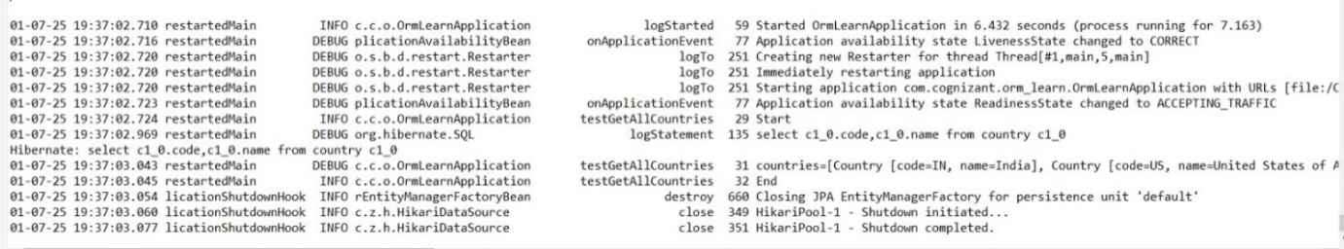
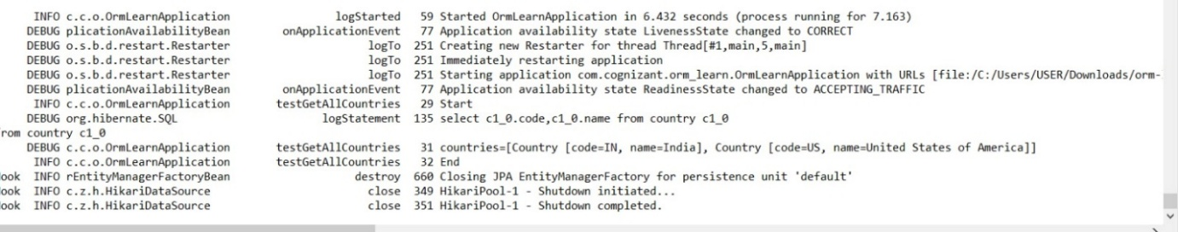

EXERCISE 3: DIFFERENCE BETWEEN JPA, HIBERNATE AND SPRING DATA JPA
APPROACH
JPA (Java Persistence API):
    - A specification (like a rulebook) for how to manage relational data in Java using objects.
    - Part of Java EE (now Jakarta EE), defined under JSR 338.
    - It defines interfaces and annotations but has no implementation.
Hibernate:
    - A popular ORM (Object-Relational Mapping) tool.
    - A concrete implementation of JPA.
    - Handles:
    - Connecting Java objects to DB tables
    - Generating SQL
    - Caching and lazy loading
    - Transaction management
Spring Data JPA:
      - A Spring framework project that simplifies JPA-based data access.
      - It does not implement JPA, but sits on top of JPA providers like Hibernate.
      - Provides:
        - Auto CRUD operations (no need to write DAO classes)
        - Repository interfaces
        - Built-in pagination, sorting, query generation
CODE
Hibernate (Approach)
Dependencies added in pom.xml
<dependencies>
<dependency>
<groupId>org.hibernate.orm</groupId>
<artifactId>hibernate-core</artifactId>
<version>6.4.4.Final</version>
</dependency>
<dependency>
<groupId>com.mysql</groupId>
<artifactId>mysql-connector-j</artifactId>
<version>8.0.33</version>
</dependency
<dependency>
<groupId>jakarta.persistence</groupId>
<artifactId>jakarta.persistence-api</artifactId>
<version>3.1.0</version>
</dependency>
<dependency>
<groupId>org.jboss.logging</groupId>
<artifactId>jboss-logging</artifactId>
<version>3.5.3.Final</version>
</dependency>
</dependencies>
hibernate.cfg.xml (File created in src/main/resources)
<?xml version='1.0' encoding='utf-8'?>
<!DOCTYPE hibernate-configuration PUBLIC
"-//Hibernate/Hibernate Configuration DTD 3.0//EN"
"http://hibernate.sourceforge.net/hibernate-configuration-3.0.dtd">
<hibernate-configuration>
<session-factory>
<property name="hibernate.connection.driver_class">com.mysql.cj.jdbc.Driver</property>
<property name="hibernate.connection.url">jdbc:mysql://localhost:3306/testdb</property>
<property name="hibernate.connection.username">root</property>
<property name="hibernate.connection.password">Divya@priya135</property>
<property name="hibernate.dialect">org.hibernate.dialect.MySQL8Dialect</property>
<property name="hibernate.hbm2ddl.auto">update</property>
<property name="hibernate.show_sql">true</property>
<mapping class="com.example.Employee"/>
</session-factory>
</hibernate-configuration>
Employee.java
package com.example;
import jakarta.persistence.*;
@Entity
@Table(name = "employee")
public class Employee {
@Id
@GeneratedValue(strategy = GenerationType.IDENTITY)
private int id;
private String name;
private String department;
// Getters & Setters
public int getId() { return id; }
public void setId(int id) { this.id = id; }
public String getName() { return name; }
public void setName(String name) { this.name = name; }
public String getDepartment() { return department; }
public void setDepartment(String department) { this.department = department; }
}
Main.java:
package com.example;
import org.hibernate.Session;
import org.hibernate.Transaction;
public class Main {
public static void main(String[] args) {
Employee emp = new Employee();
emp.setName("Samyugtha");
emp.setDepartment("Sales Manager");
Session session = HibernateUtil.getSessionFactory().openSession();
Transaction tx = null;
try {
tx = session.beginTransaction();
session.save(emp); // persist employee object
tx.commit();
} catch (Exception e) {

if (tx != null) tx.rollback();
e.printStackTrace();
} finally {
session.close();
}
}
}
OUTPUT
Successfully created database testbase
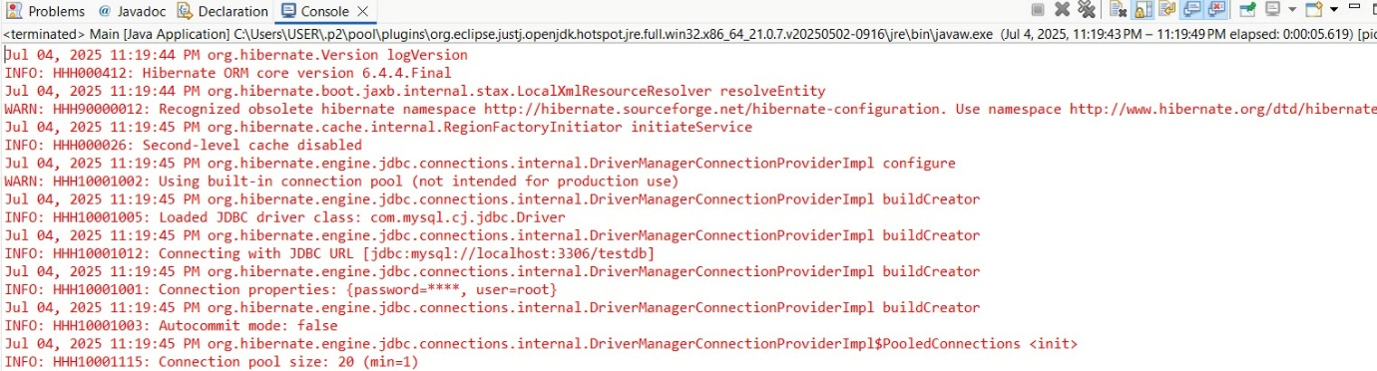
Verified in MYSQL workbench
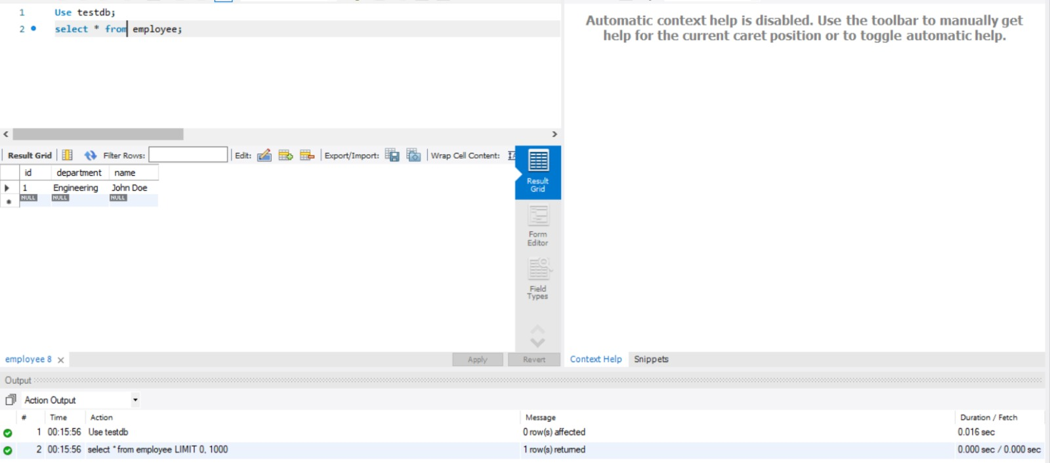
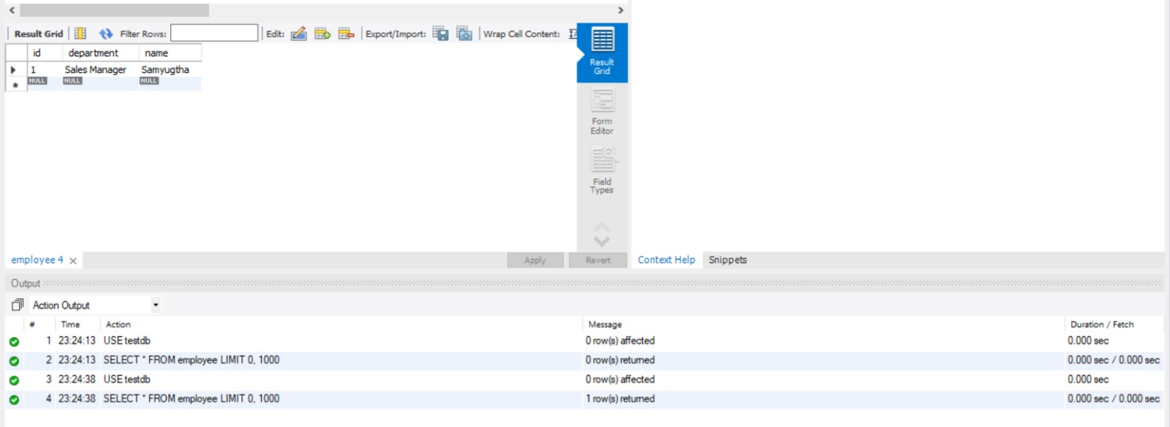

Explanation
- Hibernate config (hibernate.cfg.xml) is loaded.
- SessionFactory(Database Factory) is created once, used throughout the app.
- A new Session(Database session) is opened to talk to the DB.
- A Transaction is started and committed to save data.
- On exception, transaction is rolled back.
Spring Data JPA (Approach)
Dependencies added in pom.xml
<dependencies>
<dependency>
<groupId>org.springframework.boot</groupId>
<artifactId>spring-boot-starter-data-jpa</artifactId>
</dependency>
<dependency>
<groupId>org.springframework.boot</groupId>
<artifactId>spring-boot-starter-web</artifactId>
</dependency>
<dependency>
<groupId>com.mysql</groupId>
<artifactId>mysql-connector-j</artifactId>
<version>8.0.33</version>
</dependency>
<dependency>
<groupId>jakarta.persistence</groupId>
<artifactId>jakarta.persistence-api</artifactId>
<version>3.1.0</version>
</dependency>
<dependency>
<groupId>org.springframework.boot</groupId>
<artifactId>spring-boot-starter-data-jpa</artifactId>
</dependency>
<dependency>
<groupId>org.springframework.boot</groupId>
<artifactId>spring-boot-starter-web</artifactId>
</dependency>
<dependency>
<groupId>com.mysql</groupId>
<artifactId>mysql-connector-j</artifactId>
<version>8.0.33</version>
</dependency>
</dependencies>

application.properties (File created in src/main/resources)
# Database connection
spring.datasource.url=jdbc:mysql://localhost:3306/testdb
spring.datasource.username=root
spring.datasource.password=******* # “ ********” is the password for mysql
spring.jpa.hibernate.ddl-auto=update
spring.jpa.show-sql=true
spring.jpa.properties.hibernate.dialect=org.hibernate.dialect.MySQL8Dialect
logging.level.org.hibernate.SQL=DEBUG

Employee.java
package com.example.entity;
import jakarta.persistence.Entity;
import jakarta.persistence.Id;
import jakarta.persistence.GeneratedValue;
import jakarta.persistence.GenerationType;
@Entity
public class Employee {
@Id
@GeneratedValue(strategy = GenerationType.IDENTITY)
private Integer id;
private String name;
private String department;
public void setName(String name) {
this.name = name;
}
public void setDepartment(String department) {
this.department = department;
}
// Optional: Add getters as well
public Integer getId() {
return id;
}
public String getName() {
return name;
}
public String getDepartment() {
return department;
}
}
EmployeeRepository.java
package com.example.repository;
import com.example.entity.Employee;
import org.springframework.data.jpa.repository.JpaRepository;
public interface EmployeeRepository extends JpaRepository<Employee, Integer> {
}
EmployeeService.java
package com.example.service;
import com.example.entity.Employee;
import com.example.repository.EmployeeRepository;
import org.springframework.beans.factory.annotation.Autowired;
import org.springframework.stereotype.Service;
@Service
public class EmployeeService {
@Autowired
private EmployeeRepository repository;
public void saveEmployee(Employee employee) {
repository.save(employee);
System.out.println("Employee saved!");
}
}
SpringDataJpaDemoApplication.java
package com.example;
import com.example.entity.Employee;
import com.example.repository.EmployeeRepository;
import org.springframework.beans.factory.annotation.Autowired;
import org.springframework.boot.CommandLineRunner;
import org.springframework.boot.SpringApplication;
import org.springframework.boot.autoconfigure.SpringBootApplication;
@SpringBootApplication
public class SpringDataJpaDemoApplication implements CommandLineRunner {
@Autowired
private EmployeeRepository employeeRepository;
public static void main(String[] args) {
SpringApplication.run(SpringDataJpaDemoApplication.class, args);
}
@Override
public void run(String... args) throws Exception {
Employee emp = new Employee();
emp.setName("Samyugtha");
emp.setDepartment("Archaeology");
employeeRepository.save(emp);
System.out.println("Employee Saved!");
}
}
OUTPUT
Created database testdb

Console output after running SpringDataJpaDemoApplication as Java Application
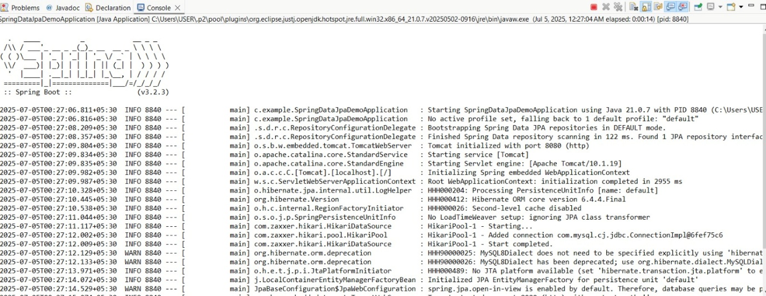
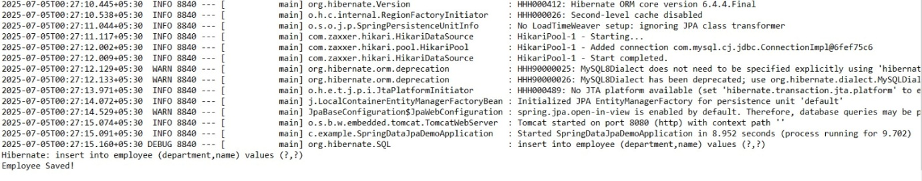
Verified in MYSQL workbench 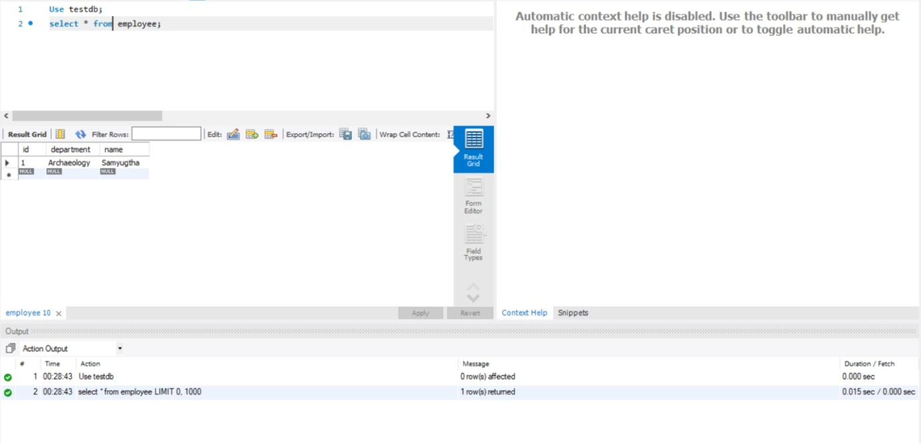

Explanation
- Spring Data JPA simplifies data access in Java by providing an abstraction over JPA and Hibernate.
- Unlike traditional Hibernate code, it eliminates boilerplate by using built-in repository interfaces for CRUD operations.
- Implemented a basic Spring Data JPA project using Eclipse and Maven, configured the application with application.properties, created entity and repository classes,
- And it also verified successful data insertion into MySQL.

